Knox Little Athletic Centre

Sponsorship Packages Season 2021-22

Knox Little Athletics Centre Incorporated
PO Box 4444 Knox City, Wantirna South VIC 3152
www.klac23.org.au
Compiled by the
Knox LAC Centre Executive Committee

About Knox Little Athletics Centre

Formed in 1968, the Knox Little Athletics Centre Inc. (Centre) caters for the athletic needs of the youth within the City of Knox and its surrounding suburbs. Knox Little Athletic Centre is one of the largest and most active centres in Victoria.

The Centre is based at Knox Park, Bunjil Way Knoxfield, in the outer south-eastern suburbs of Melbourne. Knox Little Athletics is proudly affiliated with Little Athletics Victoria and registered as centre number 23.

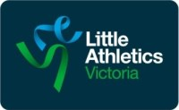
A brief history … Little Athletics started back in 1964 when a small group of children turned up for a few simple running events at Geelong. They were there for fun and fitness.
The Geelong experiment was obviously a success with now over 100,000 girls and boys now enjoying the activities of Little Athletics at centres around Australia. The Centres are affiliated with one of the State or Territory Associations which, in turn, are affiliated with the national organising body – Little Athletics Australia.

Knox Little Athletics continues to this day to provide the athletics needs of our local youth and proudly supports active participation of the children with disabilities at the centre. We have long history of high performing athletes, that have gone onto become not only state champions but progressed to become Australian Olympic Athletes. A number of our athletes have gone on to excel in other sports such as AFL and AFLW. This is testament to the good foundation that Little Athletics provides.

Our Centre currently caters for some 300-400 Athletes each season spread across 8 clubs affiliated at the centre. Competition during the summer track and field is each week, and includes various open days, regional and state events, culminating in State Championship in March. The summer season runs from September to April.

Our winter season is based around cross country event and caters for athletes all age groups and is run through to August each year. Cross country events are run each week across various venues around the Knox Area, and culminate in a State Championship.

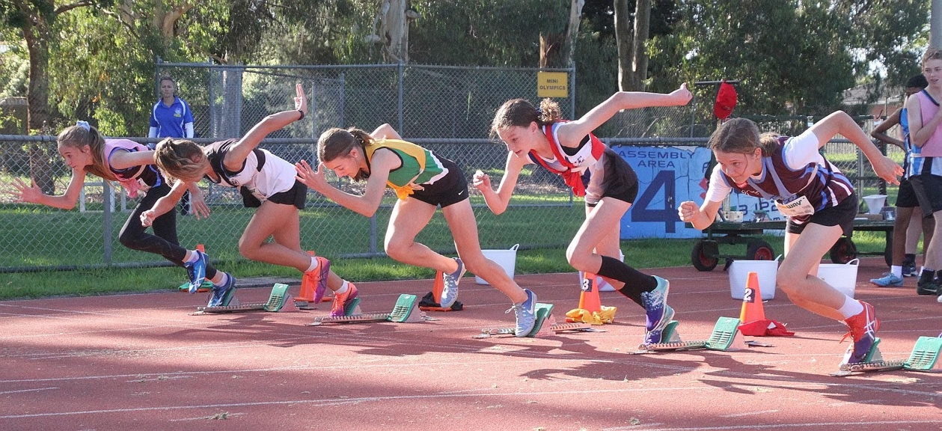

Sponsorship Packages

Standard Package
Website
- Your business name is listed, and a link is set up on our website
Social Media
- Your business is mentioned across our Facebook page which has 1200+ followers, reaches over 5000 people and have around 10,000 post engagements each month.
Email Marketing
- Your business name will be incorporated in our regular emails and website posts out to our members

$500 + GST per annum

Extended Package
Advertising & Promotion of Your Business with Ground Signage

- We can place on the fence at the venue at Knox Park a ground sign (1800x900) with your business information.
- This offer is for the display of your advertising sign for two (2) years
- This offer does not include the cost of producing the advertising sign. There is a once off charge to produce the sign ($POA) or you can supply your own.
- The sign remains the property of the advertising sponsor and therefore should the sponsor decide not to extend the sponsorship after the final sponsorship date, then the sign will be removed and returned to the sponsor.
- Payment for this advertising sponsorship must be made to the Knox Little Athletics Centre, prior to the display of the sign by the club
Website
- Your logo placed on our web site with information about your business and links to your own website.
Social Media
- Your business is mentioned across our Facebook page which has 1200+ followers, reaches over 5000 people and have around 10,000 post engagements each month.
Email Marketing
- Your business name will be incorporated in our regular emails and posts out to our members.
Visual Marketing
- Your business name and logo will be featured on a pull up banner which will be displayed at Centre events and championship days.

$1,000 + GST per annum (Minimum 2 years)

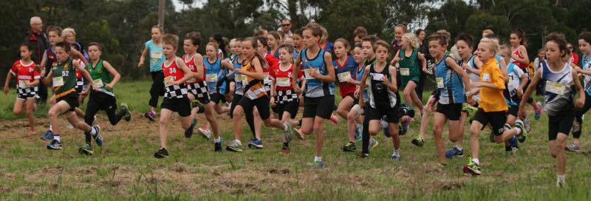

Premium Package
Advertising & Promotion of Your Business Venue Signage

- We can place on the fence at the venue at Knox Park a ground sign (1800x900) with your business information.
- This offer is for the display of your advertising sign for two (2) years.
- This offer does not include the cost of producing the advertising sign. There is a once off charge to produce the sign ($POA).
- The sign remains the property of the advertising sponsor and therefore should the sponsor decide not to extend the sponsorship after the final sponsorship date, then the sign will be removed and returned to the sponsor.
- Payment for this advertising sponsorship must be made to the Knox Little Athletics Centre, prior to the display of the sign by the club.

Website
- Your logo placed in a prominent position on our web site with information about your business and links to your own website.

Social Media
- Your business is mentioned across our Facebook Page which has 1200+ followers. We will link your page into our news feed to help with brand awareness as you provide updates through your own social media.

Email Marketing
- Your business name will be incorporated in our regular emails out to our members;
- We will also include specific information about your products and services or special offers that you notify us about [optional].

Letterhead
- Your business name and logo will be featured on our Club letterhead.

Visual Marketing
- Your business name and logo will be featured on a pull up banner which will be displayed at Centre events and championship days. Other options such a marquee walls etc can also be considered when at open days and regional events.

$2500+GST per annum (Minimum 2 years)

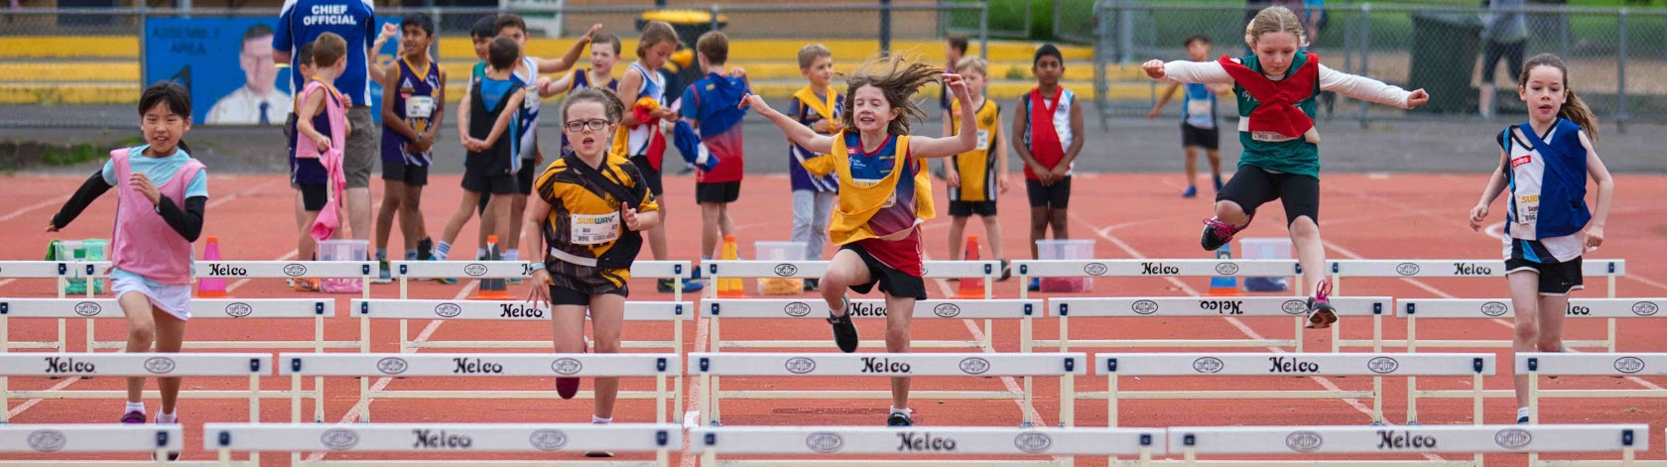

Other Sponsorship Options

Event Sponsorship such as the Gift Handicap Event
- Erection of business advertising at the finish line and the presentation area.
- Invitation to present awards to winners.
- Exclusive naming rights to event.
- Exclusive advertising on the Event Day.
- Advertising as the event sponsor on the club website & social media prior to the event.
- Your business will be recognised for its contribution through the Knox Little Athletics and social media website where winners and photos are posted.
$1000+GST per year

Venue Signage Only
- Display of business advertising sign along the track fence, with sign dimensions 1800 millimetres by 900 millimetres.
- This offer is for the display of your advertising sign for one (1) year
- This offer does not include the cost of producing the advertising sign. There is a once off charge to produce the sign ($POA). If you already have a sign you can supply it to us.
- The sign remains the property of the advertising sponsor and therefore should the sponsor decide not to extend the sponsorship after the final sponsorship date, then the sign will be removed and returned to the sponsor.
- Payment for this advertising sponsorship must be made to the Knox Little Athletics Centre, prior to the display of the sign by the club.
$500+GST per year (+ sign cost)

Shade Marquees
- Sponsor advertising on shade marquees used at Knox Little Athletics Centre during competitions days and other event days.
- This offer is for the display of your shade marquee for one (1) year
- This offer does not include the cost of producing the shade marquee. There is a once off charge to produce the marquee ($POA).
- Other options such as marquee walls only with sponsor logos can be added ($POA)
- The marquee remains the property of the advertising sponsor and therefore should the sponsor decide not to extend the sponsorship after the final sponsorship date, then the marquee will be returned to the sponsor.
- Payment for this advertising sponsorship must be made to the Knox Little Athletics Centre, prior to the use of the marquee by the Centre.
$500+GST per year (+ marquee cost)

What happens to Sponsorship money?

The majority of the funds we collect from our sponsors goes to supplying new competition implements for each event, official’s equipment such as radios, training equipment and awards and trophies.

Are there other options or ways I can sponsor?

Yes there are. Please talk to our Committee members for a solution that best suits your needs. At times we may have marquee opportunities become available spaces becoming available or signage at the venue that help run the competitions.

Who do I contact?

Please contact our Centre President David Kearsley at president@klac23.org.au or our Centre Secretary Susan Kindler Email: secretary@klac23.org.au

Knox Sponsorship 2020-21 Form

Please fill in the form below and email to Secretary@klac23.org.au
Sponsorship Type | Amount | Select
Standard Package | $500
Extended Package | $1000
Premium Package | $2500
Special Event (Gift) | $1000
Marquee | $500 + marquee cost
Venue Signage | $500+ cost of sign

Sponsor Details

Sponsor Details
Business Name
ABN
Business Address
Town |  | Postcode
Contact No | (Bus) | (M)
Email Address
Contact Person
Payment Method  Note: mobile eft is available at the club | Bank Deposit  Commonwealth Bank  Knox Little Athletics Centre  BSB: 063199  Acct: 00901917

The sponsorship amount nominated will be invoiced to the business nominated above.
A receipt can be provided upon request for tax purposes.

